October 2011 Rooted In The Land Of The Hanging Grapes Volume 38
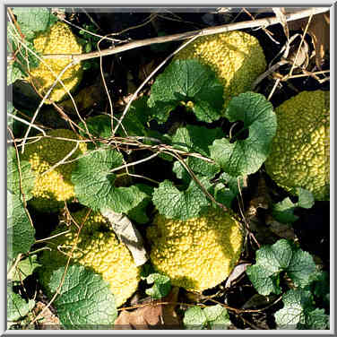
ripened Bodock fruit


The Bodock Post
October observances

Searching Paths of Old ~ Finding Guidance for the Present ~ Giving Hope for the Future

From The Arbor
For Pontotoc and the surrounding area, the month of October is a most wonderful time of the year. Football season for all levels of the sport is in full swing. The oppressive heat of summer has passed and October mornings are quite pleasant. It’s the perfect time for an early evening campfire.

Each October, those of us living in or near Dogwood Circle try to find time for a “block party.” On a chosen Saturday afternoon, neighbors gather within the large meadow-like circle for hot dogs and hamburgers, enjoying our children and grandchildren playing games, and, as darkness sets in, roasting marshmallows over one of the fire pits.

Our ritual harkens me back to a simpler time of communities where friends and neighbors strolled along sidewalks after their evening meals or sat in chairs or swings on their front porches to talk about whatever happened that day, and children played games of tag and hide and seek until called home by their moms.

In my family, we’ve long looked forward to that which awaits us near the end of October. Of my siblings, none can remember when our mom began a tradition we now call Mom’s Birthday Dinner. The meal always consisted of foods that we associated with the holidays of Thanksgiving and Christmas.

Mom would not prepare what she called cold-weather food in the summer months, and for her, chicken and dressing was a cold-weather food. But, she always made chicken and dressing for her birthday dinner, something which got all of us ready and anxious for the approaching Holiday Season.

After Mom died in ’89, my wife Barbara took up the baton Mom dropped, and we’ve continued, in unbroken succession, to celebrate the coming of the winter holidays by celebrating Mom’s Birthday Dinner on the Sunday before her 10/27 birthday or the Sunday following it. In so doing, we keep alive a family tradition that everyone enjoys.

Of course, it would not seem a proper observance without someone proclaiming the admonition with which Mom prefaced our every celebratory meal, “I hope you can eat it!”

Do you have a family tradition, something you’d be willing to share with our readers? Does it relate to the Holiday Season? If so, now would be a good time for you to submit it, as we’re accepting submissions for our November and December issues of The Bodock Post. Please consider our request. Guidelines for submissions may be found at http://rrnews.org/bp/submissions.htm.

Barbara and I leave on our Mission Trip to Kenya in October. We covet your prayers and appreciate those who’ve supported us financially. It’s not too late to donate to our effort. Follow this link, if you’d care to make a financial contribution. Alternately, you may send a check payable to Pontotoc County Habitat for Humanity, memo Kenya Trip. The address is Pontotoc County Habitat for Humanity, P.O. Box 486, Pontotoc, MS 38863.

~ By Wayne L. Carter

October Roses
By Tim Burress, Master Gardener
Cool weather is here and you should be getting ready for the October and last flush of blooms for this year. Stop all nitrogen fertilization in October; the only fertilizer to add now is a 0-20-20. Give each large bush one cup and each smaller bush one half cup of 0-20-20, sprinkle around the drip line and scratch in, water well. This will help the bushes ease into winter dormancy.
Keep up your spray program this month also, black spot and powdery mildew have not gone to sleep for the winter either. I use one half teaspoon of Honor Guard, three teaspoons of Mancozeb, and one ounce of Talstar per gallon of water. Take care to spray the underside of the foliage as well as the topside; this is just in case you have had one last case of spider mites as I have had.
If you have not had your soil tested this year, it would be a good time to do so. Your County Extension Office can provide you with soil sample boxes and will also send those samples off for analysis. The results usually come back in about two weeks and are easy to read. They will tell you if you need to amend the soil to readjust the ph.
If you have a place to store them it is time to start gathering materials for winter protection. This could be compost, mulch, leaves, or pine straw. It’s not time to add them to the beds yet, just start stockpiling them. We’ll do that next month.
Enjoy the October blooms, bring them in the house to put in vases, give them to friends, or pamper them to get them ready for a rose show.
If you have any questions or comments send me an email at colorsbytim@hotmail.com
Happy Gardening and Keep Digging in the Dirt.

Doing Their Part
By Ralph R. Jones
Wartime often brings out the best, and sometime the worst, of people. Some come to the front with no more courage, abilities, or good attributes than you or me. Some are pushed into the forefront by their profession, job, skill, ability, or simply by happenstance.

Many doctors and medical people were found in this category because of their service to mankind; their willingness to help the hurting and wounded. Heads of large corporations were sometimes pressed into a position of prominence because of their willingness to manufacture war materials and supplies. Preachers and ministers became chaplains and served with distinction ministering to soldiers around the world; often in harm’s way themselves. True Statesmen and others rose to the top in their efforts for the war effort.

Ordinary people like my dad did their thing; not because of who or what they were, simply because they were willing to perform whatever task given them. My dad had the classification of “carpenter” during the last part of World War I. He never experienced action, but his effort was with a saw and hammer; he willingly did his part. Like so many others, he did what he was asked to do.

Knockouts and snocones

Many Hollywood actors did their thing during the war. Bob Hope, and the like, entertained troops all over the world. Audie Murphy, an actor, was one of the most decorated war heroes in World War II. Many others took on “roles” in the military: James Stewart, Clark Gable, Clint Eastwood, Mr. Rogers, Earnest Borgnine, Captain Kangaroo, to name just a few. They put their lives on the line for God and Country.

Some actors, seemingly have “kicked out of the traces” today. They think that because they are seen by millions of people through TV, movies, etc. that they are somehow special and it is their “calling” in life to put down our government and the men and women who serve. Their real lives and moral conduct often makes ordinary people cringe. What they really are is often far from the parts they portray. After all, they are only playing a part, acting out scenes orchestrated by a director with words written by others. Sad to say, there are many people who cannot, or will not, see through the smoke and mirrors and go on blindly following this group.

Today many, if not most, of Hollywood is so liberal they would have us give up before we ever begin. They have little patriotism, burn our country’s flag, and would relegate our great nation into Socialism. The Barbara Streisand and Jane Fonda’s of Hollywood have gone so far as to try and convince us that the enemy is right, and we should butt out. Ms. Fonda even went over to the enemy’s side and made propaganda films that were detrimental to our country. Some actors are downright un-American! Some of these actors should be tried for treason; and if found guilty, shot; or at the very least, banished from our fair shores.

However, not all are of this persuasion, nor are they rebel rousers or liberals. One person that is near to my heart has recently had an honor bestowed on him; and rightly so. Bill Mauldin was a cartoonist during World War II, and a very good one. He served along with the ordinary foot soldiers and drew cartoons of our men who fought; those guys who, among the mud, muck, and blood; carried the battle to the enemy.

Among Mauldin’s many characters were a couple of guys named “Willie” and “Joe.” They were representative of the ordinary foot soldier who fought throughout Europe and elsewhere. Although there is nothing funny about war, Mauldin could find humor in the oddest places and bring a smile to the faces of war weary combat troops. Sometimes the cartoons hit hard at the “brass” of our forces, and on one occasion General George Patton ordered Mauldin to cease. However, when Commander-in-Chief General Dwight Eisenhower heard this, he ordered Patton to let Mauldin do his thing without hindrance. Bill never skipped a beat nor watered any of his cartoons down to accommodate anyone.

The U.S. Postal Service has issued a postage stamp in Mauldin’s honor. The stamp shows both “Willie” and “Joe,” along with Mauldin in uniform, on the stamp. What a fine tribute to a fine artist for his unselfish actions. Bill Mauldin was a fine young man who did his best with what he had.
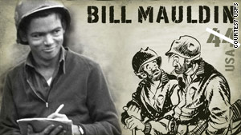
bill mauldin stamp

My encouragement to you; buy these stamps and put them proudly on your mail, Bill Mauldin was a true American, and a proud solder!

May God Bless all of you who served, or serve, in our military; regardless of what the “Fat Cat Liberals” of Hollywood say!
By Phyliss crane wardlaw
Homecoming 1959
Are you ready for some football? These words we hear often now that a new school year has begun and it’s October. Football game nights at my alma mater are known for community spirit, students, parents, alumni, and just local folks that gather down in the “holler” to support the football team, renew friendships, make new friends, and to remember “ole times.”

Football in 1959, at Pontotoc High School, my senior year was exciting. A school record was set; the team went undefeated and won the Little Ten Conference Championship.

Homecoming on Warrior Field in the 50’s and 60’s was a special night for everyone. Color, pageantry, music, participation from the student body, and, of course, football, all contributed to an evening of excitement and celebration. Every detail was planned and coordinated by Mrs. Frances Furr and Mrs. Wayne Leech.

The Homecoming Court that year consisted of
Freshman, Sophomore, Junior, and Senior Maids. These special students were Shirley Mask, Jennie Laura Witt, Jeanie Hardin, and Linda Ball. The student body would choose the Homecoming Queen by secret ballot from three senior girls, Jane McCoy, Joan Tutor, and me. Also, in the court were elementary students dressed in matching Indian costumes and feather headbands, outfits in keeping with our football team, the Warriors. These students were Dianne Dallas, Carole Butler, Scott Stringer, and Jon David Naugher.

The faculty kept it a secret as to which one of the three senior girls had received the most votes. We each had to have identical white dresses, write and memorize a speech, and practice each day as if we each had won.

The long awaited October night finally arrived. The anticipation, suspense, and excitement was almost more than I could handle. The plan was that Miss Ruth Thompson, our school principal, would go to the home of the one who had received the most votes and escort her to the stadium.
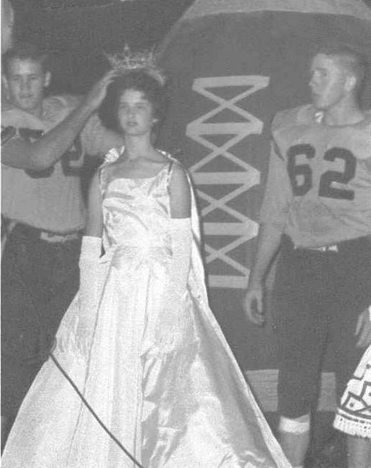
The Queen is crowned

As time approached for my family to leave our house for the school, my dad said, “It’s time to go.”
Just at that moment, there was a knock on the door. There stood Miss Thompson. I had been chosen to be the Homecoming Queen! What a surprise and honor!

The ride in the back seat of Miss Thompson’s car with the long, hooped dress was quite memorable.

As we drove out of the driveway she said to me, “Let me hear your speech.”

I quickly responded.

When I finished she said, “Let me hear it again.”
She asked me to repeat it over and over all the way to town, which was a five-mile trip. I lost count of how many times I quoted it to her.

The football teams were on the field doing their warm-up drills. The stadium was filled with students, fans, and alumni for the Homecoming game. As we drove down the hill to the edge of the field, all the lights were turned off. Remember, it was still a secret as to who the Queen would be.

On the fifty yard line a seven-foot tall football had been constructed and erected by Mr. Don Mallard’s shop classes. I made my way across the field (in the dark and between football players) to this football where I was to be enclosed until the program started.

I still had time to say my speech a few more times while holding on to a metal pole and standing on a narrow platform. At the appointed time the football was opened, I stepped out and Co-Captains of the team, Herbert Jenkins and Gene Turner, crowned the 1959-1960 Homecoming Queen, which was a very humbling experience for me.
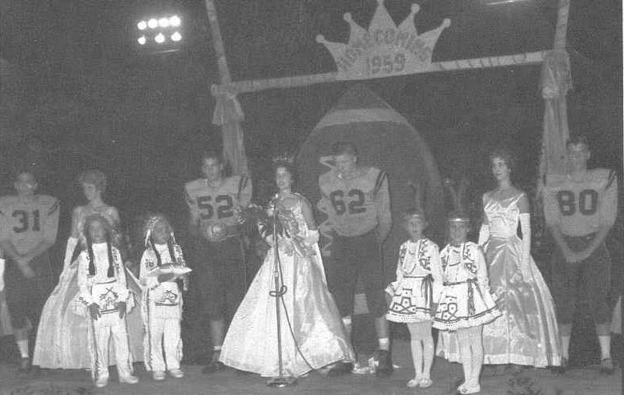
Quite a production

Thanks to Miss Thompson and that five-mile ride, I still remember that speech today. Here it is!

“Sometimes words fail to express our true feelings. I find that this is true with me tonight. Anyway, I can say thanks, thanks again for this lovely honor.”

These words still express my feelings after fifty-one years.

Biographical Sketch: Phyllis Crane Wardlaw was born to Horace and Ann Crane, the second of six children and grew up in the Longview Community of Pontotoc County, Mississippi. She went to school at Longview through grade eight, at which time Longview students were consolidated into the Pontotoc City Separate School District.

Phyllis and husband Bill, a United States Navy Retiree, have four children, seven grandchildren and one great-grandchild. She is a sports’ enthusiast and an avid reader of all types of literature. Home is where the heart is, and that is where Phyllis can be found still taking care of her family with love and devotion. Click here for more information.

by wayne l. carter
A Slinging Memory
From a historical perspective, the sling preceded the slingshot, but for me it was the other way around. I had a homemade slingshot a long time before a sling. I cannot remember who introduced the sling to me, though perhaps the deed was handled by some of my cousins or by boys in my neighborhood.
Slingshots were easy to make using simple tools and readily available materials. A small tree limb with a Y-shaped branch would form the handle and arms of the slingshot and could be carved crudely or handsomely, depending upon one's skill. A small patch of leather was needed to hold the projectile or ammunition being shot, and such a piece of leather could be formed from the tongue of an old pair of leather shoes. The only other critical piece needed was the rubber bands that connected the leather pouch to each arm of the slingshot, and since those were the days when automotive tires required rubber inner tubes, the availability of used inner tubes was high.
While not every family saved old inner tubes, enough folks did to allow plenty of material for slingshots. Once the rubber strips were cut and tied to the arms of the slingshot and to the leather pouch, a youngster was ready for hours of fun. A few, fortunate youngsters might have had access to steel ball bearings to shoot in their slingshots, but most of us country boys used "gravel rocks."
Slingshots are not much fun to shoot unless they are targeted at something. In my neighborhood, tin cans, cats, birds, and some dogs made for interesting shooting. I don't recall ever hitting a living thing with a slingshot, but I had plenty of fun trying.
A sling is a less complicated device than a slingshot. Like the slingshot, it has a leather pouch to hold the projectile, but its power is not derived from stretched rubber bands. The sling is basically a pouch centered between two cords or narrow strips of leather. Swung rapidly overhead or alongside the user, centrifugal forces provide the sling its power, and that power can be lethal.
Though the sling is a simple weapon, it was made famous in the battle between David and Goliath of Biblical fame. In the days that I attempted to harness the power of the sling, I never developed the skills mentioned by David as he defended his ability to slay the lion and the bear with a sling. With my skills, I don't think I could have come close to wounding either beast, let alone burying a stone in the forehead of a giant on my first attempt. However, as surely as the Lord was with David when he battled the Philistine giant, he was with this writer many years ago involving an incident with a sling.
I would have been around the age of twelve or thirteen at the time. The incident happened as Keith Gillespie and I were honing our respective "slinging" skills. I was in a neighbor's yard, slightly in an uphill line from where Keith stood on the street below. The lines of his sling became tangled as he released one of them to send his rock flying. His intended target was in a direction away from both of us. The rock was errantly hurled directly toward me with blinding speed. I'm not sure I saw it coming, but I felt it as it struck my chin. It hit with a thud, and I still remember it took a minute or so for me to feel the pain, as though the nerves in my face were too stunned to transmit the signals to my brain.
I also remember being scared I would have a disfiguring scar. It was not that I had a pretty face, but with all the other insecurities of my early pubescent years, I didn't want to be nicknamed "scar face," too. Fortunately, the facial cut produced was less than a half-inch, and the ensuing scar slowly slipped below my chin as I grew. No one ever had reason to call me "scar face," and as far as I can remember, I never truthfully explained to Mom how I cut my chin.
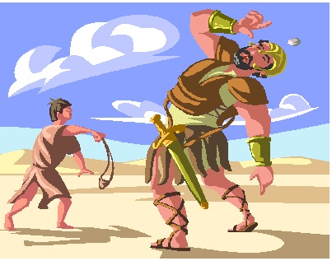
simple but deadly

Mom was fortunate to have raised my older brother past his first few years, as he was prone toward self-inflicted injury, and her fretting over "Freddie" would carry over into the lives of all four of her children. Had Mom known about the "sling-thing," she'd have worried herself sick, and, thereafter, every time I wanted to play somewhere I would have been warned about the deadly potential of slings and would probably have been prevented from participating in a lot of boyhood outings.
I may not have had much sense in my youth, but I had enough to know I was lucky. I came out of the sling incident smelling like a rose. I could have easily lost an eye, a few of my permanent teeth, or my life, for that matter. I did not realize it at the time, but I have come to acknowledge my luck was not really luck at all. Rather it was something akin to divine intervention, or perhaps it was intervention by an angelic being that thwarted the course of a rock that might have otherwise produced a disaster in my life. You have the right to believe differently, but that's my story, and I'm sticking to it.

Down Candy Lane
by newt harlan, humble, TX
Have y’all noticed that many of our fondest childhood memories are identified with candy? I’m sure everybody remembers beginning in September to anticipate the big haul of sweets we were going to make from “trick or treat” at Halloween. Then it was only a few weeks later until Thanksgiving when there were always homemade treats such as divinity, pralines and fudge to anticipate. Then in only a couple of weeks all the Christmas celebrations began.

Everybody has some fond candy memories of Christmas. Do you remember candy canes? They pretty much were a hallmark of Christmas and someone was always passing them out during the holidays. You could be sure at least one of the stores visited while Christmas shopping would be giving out candy canes and they were always passed out at school parties on the last day before the Christmas break. Also, there were always some hung as decorations on the Christmas tree and at least one stuck in the top of our stockings.

Unfortunately, there was frequently a small problem with sugary treats such as candy canes, other hard candies-- our coastal humidity often made candy sticky and the wrapper would stick to the candy, the candy would stick to our fingers, and our fingers would stick to everything else such as door knobs, faucet handles, and clothing. At school holiday parties we often got as gifts colored cardboard boxes filled with various hard candies and tied up with colorful ribbons. Frequently, the humidity caused the candies to stick together so we'd have to put giant chunks in our mouths and for the rest of the day, every child was going around sucking on candy chunks for all they were worth.

When I was around 9 or 10 years old, daddy brought home a peppermint candy cane that was at least 4” in diameter and two feet long. That thing stayed around several years, going on display every Christmas until finally one year we discovered the rats had been gnawing on it during the year while it was in storage and it made a fine holiday treat for our livestock.

During the holidays there was always plenty of homemade divinity, pralines and different kinds of fudge at home and at all our friends’ houses and parents always seemed to be more liberal about allowing us to enjoy treats during the holiday season than they were during the rest of the year.

Besides all the homemade goodies, folks always put out dishes filled with mints, colored hard candies, and that thin wiggly, ribbon candy. As I recall, none of it ever lasted too long. Do y’all remember those hard candies with the pictures in the middle? We could never figure out how they got those pictures in the center.

It was only a short while after Christmas that we started looking forward to Valentine’s Day when many girls and a few boys got red heart-shaped boxes filled with chocolates that were once in a while shared with friends. One thing that we all got was packets of little heart-shaped candies with sayings like Be My Valentine, I Love You, 23 Skidoo, Hello Beautiful and many other mushy and humorous imprints on them.

my oh my these are good

Naturally, during the times in between holidays there always were trips to the neighborhood grocery store (precursors to convenience stores) with saved up pennies and, if the planets were aligned just right, a nickel or two.

If we were lucky enough to have a nickel, a Holloway sucker was a good bet. This was often called an “all day sucker” since it seemed to take forever to eat, and it was fun--first I'd soften the chocolate taffy-like candy, then pull the end with my teeth so that strands hung straight out. Sometimes, when my sisters and I all had Holloways, we’d have contests to see who could stretch their candy the farthest.
by ralph r. jones
A Holloway wasn’t the only thing you could get when you had a nickel. There were Milk Duds, M&M’s, Baby Ruths, Butterfingers, Tootsie Rolls and a plethora of other candies from which to choose. However, the nickel candies were never as much fun to select, as were the penny candies.

Picking out penny candy was one of the most difficult tasks we had to face as kids.--With a couple or three pennies in our hands, we'd lean on the glass counter and look at row after row of choices. A Mary Jane lasted forever and could take out fillings. Flying Saucers had these small beady things in the middle and had no taste at all. Root Beer Barrels tasted good to start with, but just got boring after a while. Bubble gum meant blowing bubbles and eventually getting gum stuck to your face when the bubble burst. Fireballs seemed to be hotter back then, and we'd hold them out of our mouths for a while to give the flames time to subside. Candy cigarettes made us feel sophisticated, and we'd hold them the way we’d seen adults hold their real cigarettes. There were Necco wafers and Tootsie Rolls and those little Coke bottles made from wax and filled with sugar water. The choices were endless.

My sisters always made their choices quickly and soon had their candies sacked up and were ready to get started tasting their treats, but I was a shopper and it took forever for me to make up my mind. I had no real favorites, like all kids, I loved just about any candy you could name.

Finally, usually after mama told me, “If you don’t hurry up and pick some candy, you’re not getting any,” I’d make up my mind and pick out just exactly the pieces I wanted, and the lady behind the counter would count them out, take my money and put the candy into a little paper bag for me.

After making our selections, we’d rush out to the car to begin our sugar feast. My youngest sister and I always dug right in to ours, and by the time we reached home all our candy was gone. Linda, our middle sister, was more conservative and slowly enjoyed her choices. In fact she’d often horde her choices for a day or two and taunt us by slowly licking a sucker or eating a piece of hard candy with great gusto, knowing we had none. No amount of begging could make her share--she’d just tantalize and nyah, nyah, nyah, nyah.

Yes, many of our childhood memories are tied to candy, and Linda I want you to know that even after all these years I still haven’t forgotten that you were a stingy gut and wouldn’t share with us.

Everlasting Mules
By now most of you know of my longtime fascination with the mule. How long has our four legged, long eared friend with the funny sounding bray been around? There is probably some “egg-headed” historian, or scientist around somewhere that claims to know, but he’s probably “just whistling Dixie,” as they say. Mules have been around for a long, long time.

I was wondering one day if the Bible had anything to say about the mule. Donkeys and mules are both mentioned several times in scripture, but I thought they might use the term donkey and mule interchangeable. You know many folks do that today. It’s sort of like a mouse and a rat. Many think that a rat is just a full grown mouse. WRONG! They are two separate animals just as the mule is not just a donkey on steroids. They are separate and distinctly different animals.
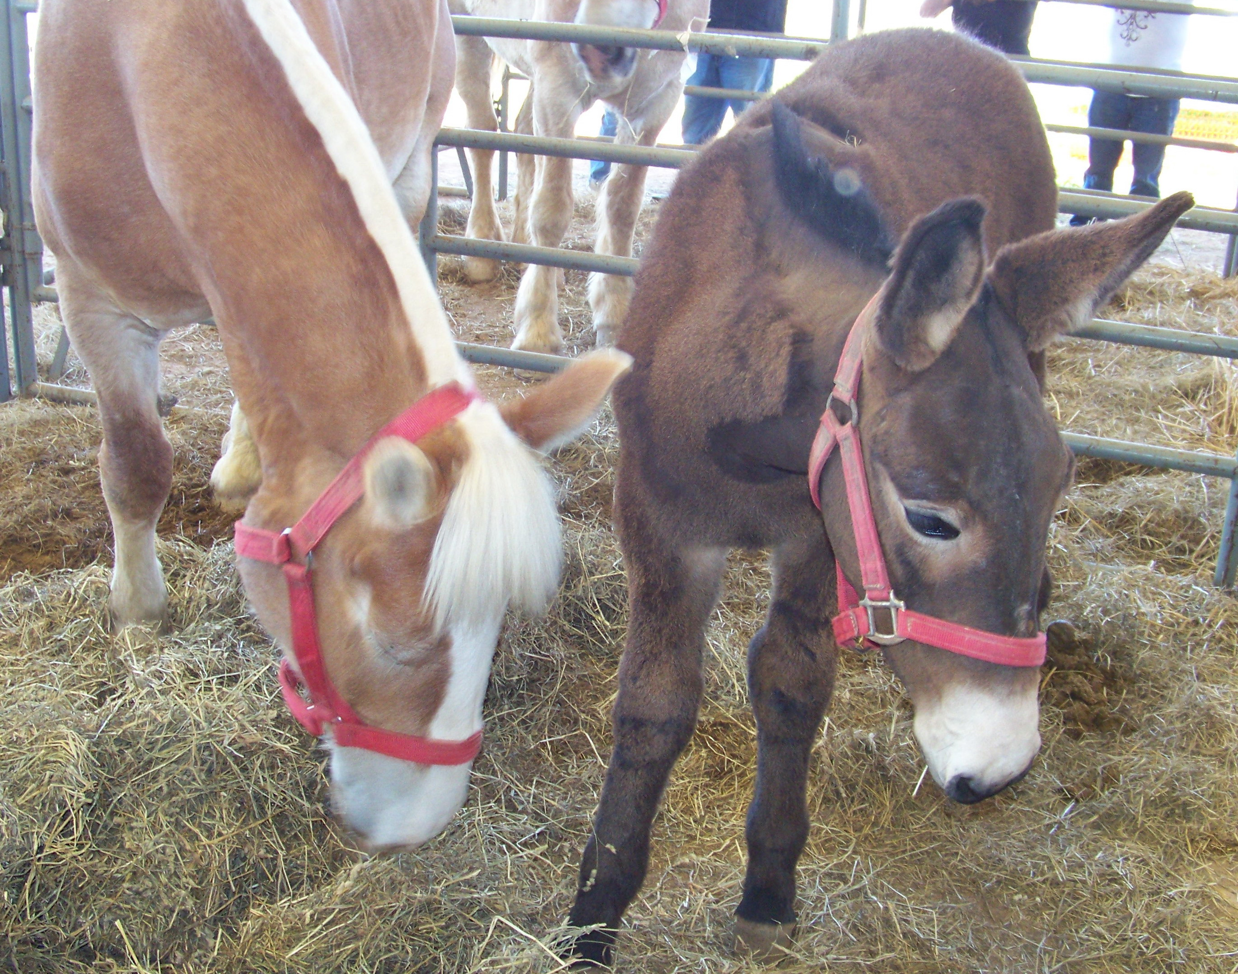
mule colt

In searching the Bible, I found, that there are many mules mentioned there. Although, there is not a lot of text devoted to the mule, there is enough said that we know mules were prized animals and that donkeys and mules were most definitely separate animals.
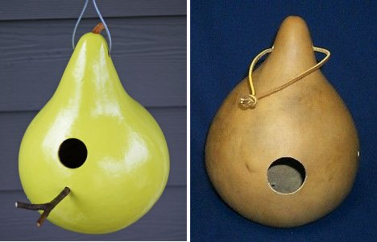
gourd bird houses

Many kings, noblemen, priests, and prophets of Biblical days rode mules. Mules were kept by many dignitaries for their own personal transportation. King David, instructed Zadok, the priest, and Nathan, the prophet, and others to go and anoint Solomon as the next king of Israel, he sent with them his own “Kingly Mule” for the new king to ride (I Kings 1:32-38, 44).

You will remember Absalom, the son of King David, was riding on a mule during battle, rode under a tree, he was caught in the branches, and his mule ran out from under him. Absalom was killed while hanging there (II Samuel 18:9).

To quench my curiosity about the use of the term mule and donkey I searched more scriptures. I found out that there were mules and donkeys mentioned in the same passages and were counted separately in their listing. When the Children of Israel were coming out of many years of Babylonian captivity the scripture listed some of the things returning with them and it included; 736 horses, 245 mules, 435 camels, 6,720 donkeys (Ezra 2:66-67).

There is no way of knowing when the first mule came into existence. The first mule could have been derived from the wild, or possibly from some good animal husbandry, or the Lord may have just created a few in the beginning. It is unusual that a Jack (male donkey) and a Mare (female horse) would be compatible enough to produce a mule hybrid. The horse has 64 chromosomes and the donkey 62, the mule is born with 63 chromosomes. There are male mules, called “John Mules,” and female mules, called “Molly Mules,” but they cannot reproduce. Only in the rarest situations of the entire history of the world has a mule ever reproduced, and that has been a matter of speculation ever since.

Something that must be realized is if all the mules in the world were eradicated and the entire mule population totally gone for the next thousand years or more, a new mule could still be born. Its characteristics would be the same as they are today, or as they were 2000 years ago. Small hooves, large head, long ears, a kicking set of rear feet, and a distinctive bray; yes, they would all be there just as before. The same attitudes and characteristics would still be intact. The size, color, and appearance could still be, to a certain extent, determined beforehand by its parents; small parents yield small mules, large parents yield large mules, etc.

If Noah did, in fact, bring a male and female mule on the ark, he did it for his own riding enjoyment, not to re-populate the earth with mules. He had a male and female horse to carry on their strain and the same for the donkey, but not the mules. No doubt, after the flood, Brother Noah took the opportunity to breed a few mules for use around the “New Farm.”

For a while there, at least, the entire world was “mule-less.”

Gourd Points
by tim burress, master gardener
Gourds are a fun vegetable to grow and are a member of the Cucurbita family, which include pumpkins and squash. Gourds are also easy to grow and are grouped into three major categories; ornamental, hard shell, and luffa.
Ornamentals, as the name implies, is for decorations and ornaments. These bright and colorful gourds will spruce up your Halloween, Thanksgiving and other fall displays. Hard shelled are the larger and longer gourds that are used to create bird houses and other craft projects. Luffa is also known as the sponge squash. It is actually grown for use as a sponge.

Gourds grow in all kinds of shapes, colors and designs. The challenge in growing a variety of gourds is cross pollination. Cross pollination is a trait of the cucurbita family, so if you want a variety of gourds, plant lots of seeds and let the birds, bees, and butterflies do their job.

The most popular is the hard shell or birdhouse gourd. People grow and dry these hard shelled gourds mainly for use as birdhouses. Hard shell varieties require 110 - 130 days to grow to maturity. Gourds take a long time to dry. The small ones take at least a month and the long gourds that are used for crafts and birdhouses, can take six months or more.

Here are the basics for drying gourds. Clean your gourds with a solution of water and a disinfectant or bleach to kill any bacteria. Place gourds on a screen or a board, making sure that they do not touch each other. Store them in a cool, well-ventilated area. Gently move them each day or two and wipe off any moisture that is on them. Moisture is natural, as they are perspiring off the water content, which is about 90% of their weight. Fungus on them is not abnormal. They are okay unless they develop a soft spot. If a soft spot is found, discard it.

Gourds are dry when the seeds inside rattle. At this point the gourd will be very lightweight and fragile. Once they are dry, you can make a wide range of crafts and they can be painted, shellacked, or left unfinished. Birdhouse gourds can be made into just about anything, including vases, flower pots, bowls, dishes, ladles.

Ornamental gourds are usually smaller and will come in a wide variety of shapes, sizes, and colors. Ornamentals grow to maturity in 90-100 days and are most commonly used as decorations in fall displays.

The luffa gourd is used as a sponge, just as its name implies. It also grows to maturity in approximately 100 days.

When planting, sow four or five seeds in hills, with the hills spaced four to five feet apart. Space rows five to ten feet apart, depending upon how much space you have. The more space you provide, the less overcrowding, and the more and larger the gourds. Thin to two to three seedlings per hill. When planting in rows, space seeds five to six inches apart.

Gourds are grown like pumpkins and squash. They like warm weather and lots of fertilizer. The soil should drain well, contain lots of compost, and be kept moist. Gourds are a vining plant and grow well on fences or a garden trellis. Fencing is great for the smaller, ornamental gourds or try growing them in a large container, and hanging them off your deck. The main advantage of fencing, is the gourd grows with less blemishes, because there is no contact with the ground. The larger hard shelled variety will do better sprawled on the ground, as the larger fruit can break off the vine if suspended.

Cucumber beetles, aphids, slugs and snails and squash vine borers are pests that like to attack gourds, so you will need to keep an eye out for them.

Gourds are affected by a range of fungi, with the most notable being downy and powdery mildews. Begin a fungicide treatment as soon as signs occur or better yet, apply fungicides before the fungus hits. Start treatments when the hot and humid summer weather begins in your area.

Gourd plants do not like frost and a late spring frost will kill tender seedlings. Make sure to cover them if the threat of frost exists. The gourds themselves however, are not harmed by frost or freezes.

Harvest in the fall after the first frost as a heavy frost will not harm a mature crop. Some people say to harvest them before the frost. I have read of growers and crafters who actually leave them outdoors all winter long, letting nature do the drying. They believe the gourds dry more naturally, with far fewer problems with mold. When harvesting, leave as much stem as possible because you can always trim the stem to the desired length and look when finishing them.

Happy Gardening and keep digging in the dirt.
by wayne l. carter
Fat Folks
What with all the fat folks one sees while shopping, driving, walking in airports, attending ball games, eating in restaurants, strolling along the beach, hiking in the mountains…well, I don’t know about the mountains, because I’ve not been hiking there, but almost everywhere else, the proverbial “woods” are full of them.

I’m dating myself, but I can actually remember when majorettes for marching bands were – dare I say it – skinny. Okay, not exactly skinny, but definitely with far less poundage than presently found in marching bands.

Maybe, it’s just me, but fat folks seem to be more prevalent at Walmart, supermarkets, and restaurants. I’m not sure why that is, but I think it has something to do with them “feeding their habit.”

I’m not really a patron of the arts, so my expertise regarding the masters is suspect, but I remember reading that the reason so many of the masters’ nudes and partially nude women were fat was because they represented the complete woman of that era. It may be true, but I’m not buying that explanation. I figure the artists couldn’t get pretty women to take their clothes off and pose. They simply painted subjects available to them.

It once was you’d see only one or two really fat folks in a crowd, but not anymore. They’re more the norm. Why do you suppose that is? How did we get so many fat folks in my short lifetime, or perhaps the past thirty years? Do you reckon it’s because of high calorie baby milk?

A bridal veil?

I have several theories. Children are too fat because they don’t get the exercise some of us did growing up. Some of you, who read my musings, did farm chores in your childhood and teen years. For sure, there was no TV to sit in front of all summer long or well into the wee morning hours. And, more than likely, your bunch received plenty of exercise ripping and romping on the playground at school, participating in the school’s Physical Program or in extracurricular activities.

It goes without saying today’s children are well fed. Though, they’re probably not ‘better’ fed than my generation. Meat was seldom served at our dinner table, and vegetables were the norm. There were no fast food restaurants to ‘biggie-size’ our meals, and no all-you-can-eat restaurants, but if there had been, there wasn’t money in the household budget for eating out.

Doubtless, the better standard of living we enjoy in America has contributed to our expanding waistlines simply because most folks have enough income to eat out and exercise poor choice with regard to healthy eating. The restaurant and ever-expanding fast food industry don’t help matters by serving larger than necessary portions with 1,000+ calorie entrees.

If my use of the term fat folks is offensive, perhaps I should say extra-large people. Either way, whenever I encounter an extra-large (weight wise) family, I notice that large parents seem to rear large children. I look at those extra-large adult bodies and wonder why they’d wish their size upon a sworn enemy, let alone upon their own children. Nonetheless, restraint appears to be a concept the parents have yet to grasp.

A song from the Seventies seemed to mock short people and did in fact offend a number of persons of diminutive stature. I imagine a song deriding fat folks would be even more offensive, even though most fat folks can make lifestyle and dietary changes to improve their lot in life, while the best short people can do is purchase platform footwear.

Fat folks are not necessarily fat because of poor choices, but most are in this category because of their choosing poorly. Personally speaking, I’m larger (fatter if you prefer) than I should be. I could exercise more and adopt healthier eating habits, but I’m comfortable with my physical condition. I perform enough physical work to keep my large muscles in good shape, and I eat whatever I want to eat. My cardiologist is happy, and my gastroenterologist is happy, and I’m happy. I suppose it’s true that fat folks are happy folks.
dallas deals with Uninsured autos
Bubba Bodock
While we’ve not verified the truth of all the following, we do know that such an ordinance went into effect and enforcement started in January 2009:

Recently, the City of Dallas, Texas, passed an ordinance stating that if a driver is pulled over by law enforcement and is not able to provide proof of insurance, the car is towed.
To retrieve the car after being impounded, they must show proof of insurance to have the car released This has made it easy for the City of Dallas to remove uninsured cars.
Shortly after the "No Insurance" ordinance was passed, the Dallas impound lots began to fill up and were full after only nine days. 80 + % of the impounded cars were driven by illegals.
Not only must they provide proof of insurance to have their car released, they have to pay for the cost of the tow, a $350 fine, and $20 for every day their car is kept in the lot.
Accident rates are going down and... Dallas' solution gets uninsured drivers off the road WITHOUT making them show proof of nationality.
Wonder how the ACLU or the Justice Department will get around this one?
Just brings tears to my eyes.
GO Dallas!
.
Old Newt Says

According to a recent survey, something like 78% of Americans aren’t happy with their physical appearance and would like to change it. Improving their intelligence is of concern to only something like 13% of those surveyed. Apparently, pretty trumps smart by well over 4 to 1. I suppose that places those of us who are both ugly and dumb pretty much completely off the radar.

Life is kind of like making a pot of chili, you taste it and if it needs something, you add that. Like good chili, you’ll still be adding a little here and a little there when it’s finished.

The truth is a mighty important thing in life, but you have to be awful careful not to let it get in the way of a good story.

Note: Old Newt writes the weekly email, “Honest Lies and Other Misguided thoughts.” To subscribe please contact editor@bodockpost.com.

Cuzin’ Cornpone
by Ralph R. Jones
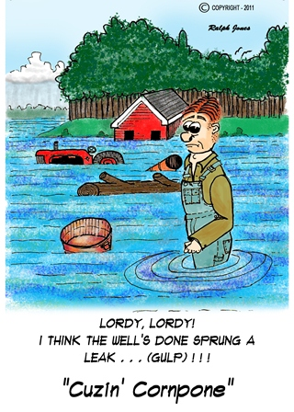

a bodock post exclusive
Our loveable friend, Cuzin Cornpone, is published only in The Bodock Post.

